TEAM: Code Duckies
Semester and Year: Fall 2021

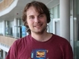 | Name: Anthony Simard
 |  | Volume?  Loud  Good  Too low | Eyes/connection  Good  spotty  poor | Comments:
  Practiced?
  (5=best)
  5
  4
  3
  2
  1

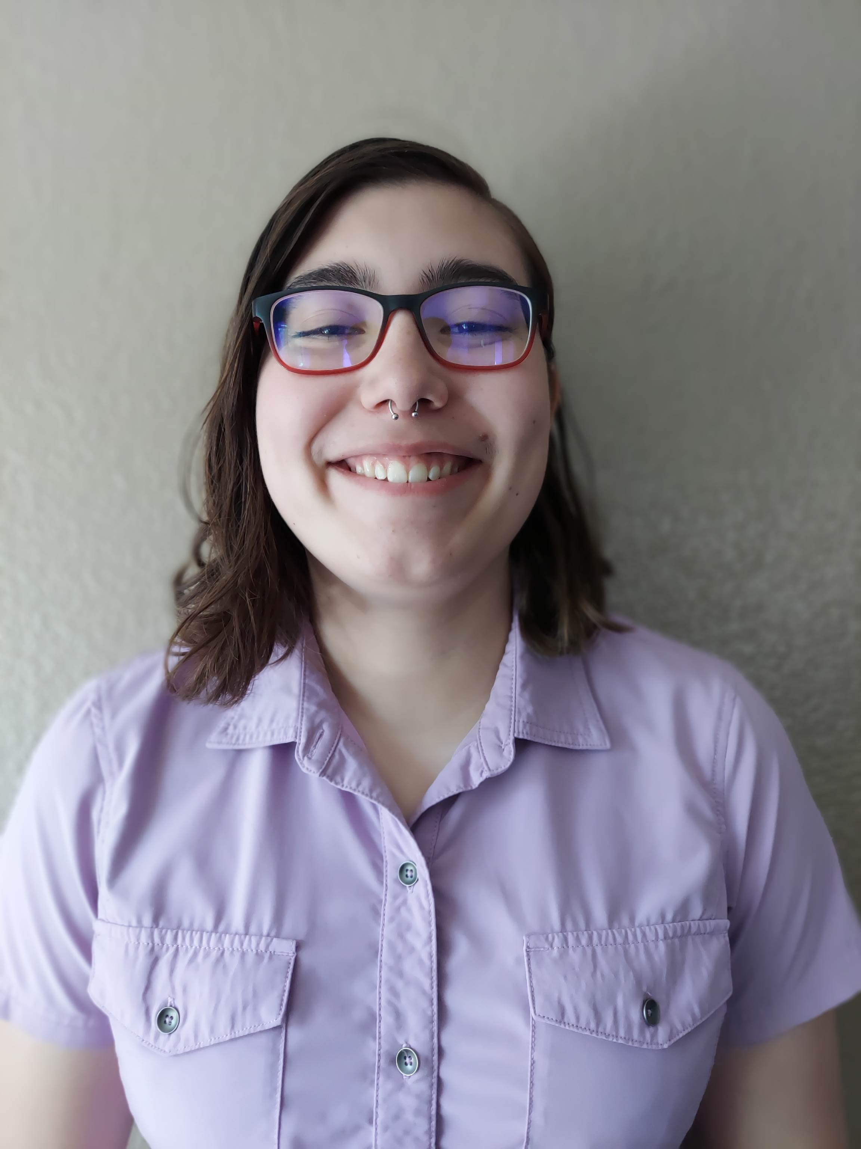 | Name: Ari Jaramillo
 |  | Volume?  Loud  Good  Too low | Eyes/connection  Good  spotty  poor | Comments:
  Practiced?
  (5=best)
  5
  4
  3
  2
  1

 | Name: Chris Cisneros
 |  | Volume?  Loud  Good  Too low | Eyes/connection  Good  spotty  poor | Comments:
  Practiced?
  (5=best)
  5
  4
  3
  2
  1

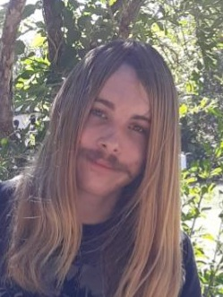 | Name: Daniel Rydberg
 |  | Volume?  Loud  Good  Too low | Eyes/connection  Good  spotty  poor | Comments:
  Practiced?
  (5=best)
  5
  4
  3
  2
  1

 | Name: Jacob Heslop
 |  | Volume?  Loud  Good  Too low | Eyes/connection  Good  spotty  poor | Comments:
  Practiced?
  (5=best)
  5
  4
  3
  2
  1

